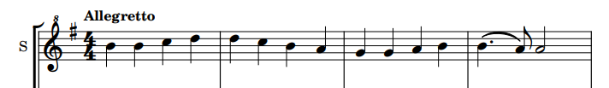
Question 0 (0/1)
Looking at the visual information on the image, can you find any kind of music representation in it? Answer only with “Yes”, if there is any kind of music representation on the image, or “No”, if there is not.
1 | “Yes” (for all scores)
0 | “No”
Question 1 (0/1)
What type of musical notation is used in this excerpt? Choose between: modern notation, tablature, mensural notation, Korean notation, “other notation” or “no music notation present”. Answer only with the name of the musical notation used in the excerpt.
1 | “Modern notation”, “Common western notation”... (for all scores)
0 | Any other answer
Question 2 (0/1)
Based solely on the music sheet image provided, can you determine which musical work this excerpt belongs to? Please use the melody’s rhythmic patterns, note sequences, and any other musical clues to make your deduction.
1 | Symphony No. 9 in D minor, Op. 125 “Ode to Joy”, by Ludwig van Beethoven
0 | Any other answer
Question 3a,b,c (SER)
Please transcribe the contents of the given music excerpt in the Kern formats. For your information, Kern/MusicXML/ABC format is a text-based format for encoding musical scores. Ensure the excerpt's musical notation is accurately encoded in the Kern/MusicXML/ABC syntax, capturing the pitch, rhythm, and any relevant musical details.
Make sure you are familiar with the Kern/MusicXML/ABC format when performing the transcriptions. Provide the transcript only for what is visible in the image, even if you have more knowledge.
SER | Compare the model’s transcription with the ground truth.  This agreement will be computed automatically, not by the evaluators.
Question 4 (1-5)
Can you determine the tonality (key) of the given music excerpt? Please explain the steps and reasoning behind how you arrived at this conclusion.
When determining the tonality, consider the following factors:
- Key signature: Whether there are any sharps or flats.
- Accidentals: Notes altered by sharps, flats, or naturals outside of the key signature.
- Melodic structure: The shape and direction of the melody, including important pitches and phrase endings.
- Harmonic implications: Some melodies imply certain harmonic progressions or tonic-dominant relationships.
Provide a clear explanation of your process, detailing how each of these elements contributes to your conclusion about the tonality.
5 | The reasoning contains:  - “The key signature shows one sharp (F#) [Fa#]”  - “The melody has a predominance of the notes from the G Major chord (G, B, D) [Sol, Si, Re]”  - (alt) “Predominance of G, B and D: tonic, mediant and dominant in G Major, respectively”  - “There are no accidentals”  Conclusion: The key tonality is G Major [Sol Mayor]
4 | The reasoning contains:  - “The key signature shows one sharp (F#) [Fa#]”  - The reasoning is not completely correct or does not mention the most common notes  Conclusion: The key tonality is G Major [Sol Mayor]
3 | The reasoning contains:  - “The key signature shows one sharp (F#) [Fa#]”  Conclusion: The key tonality is G Major [Sol Mayor] or E minor [Mi menor]
2 | The reasoning contains:  - The key signature is mistaken, but only a single symbol up or down: in this case, it could say it has two sharps (F#C#) [Fa#, Do#]
1 | The key signature is mistaken
0 | The model admits they do not know and provide no clear answer

Question 5 (1-5)
Based on the musical notation present in the image, what instrument do you think it is intended for? Your task is to analyze the musical notation and use the melody's structure, rhythm, and characteristics to deduce the most likely instrument the musical work was written for.
5 | The reasoning contains:  - “The notation is simple and clean without instrument-specific markings or techniques that would suggest a particular instrument.”  - “The staff is marked with "S" at the beginning, which is a standard abbreviation for Soprano.”  - “The Sopranino clef [ver pregunta 8c para otros nombres] suggests a high-pitched instrument”  - “The rhythmic pattern is extremely simple”  Conclusion: “Recorder”, “flute”, “high-pitched woodwinds”, "beginner level”
4 | The reasoning contains:  - “The staff is marked with "S" at the beginning, which is a standard abbreviation for Soprano.”  - Mentions the treble clef instead of a transposing G-clef.  Conclusion: “flute”, “high-pitched woodwinds”
3 | “Flute”, “high-pitched woodwinds” but the reasoning does not mention the previous arguments or hallucinates.
2 | “Choral score for a soprano”
1 | Does not mention the melody being high-pitched at all. Incorrect instrument.
Question 6 (0/1)
Based on the musical notation present in the image, what is the time signature?
1 | “4/4”
0 | Any other answer
Question 7 (1-5, cuántos identifica correctamente)
In this excerpt, are the following symbols present?
Quarter note (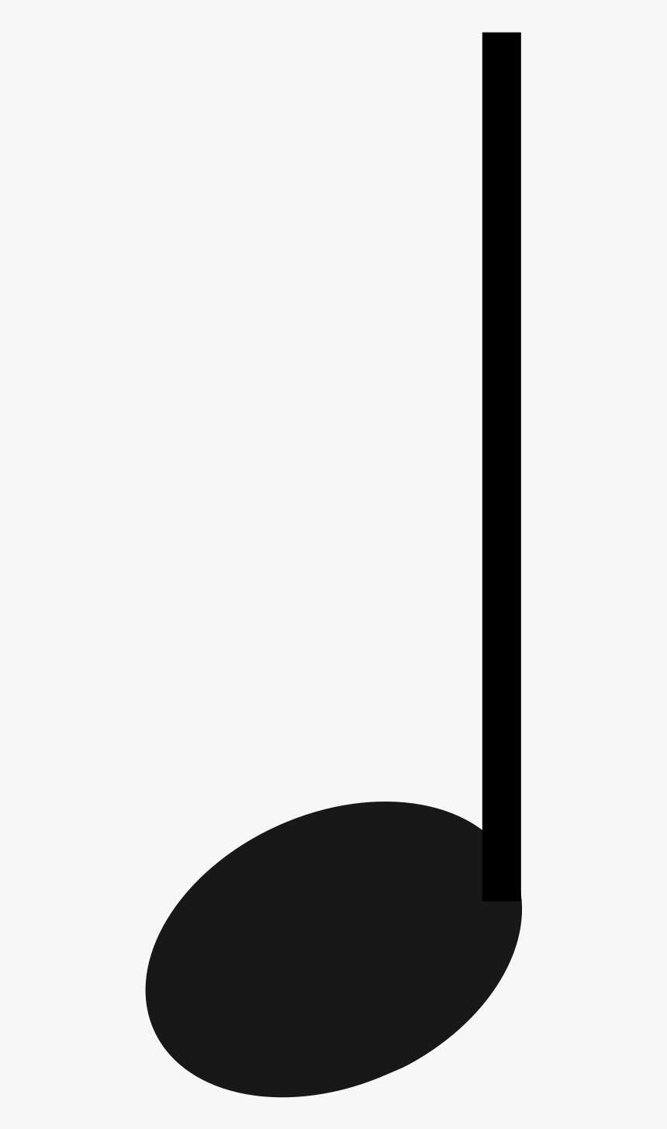) | Yes
Whole note () | No
Crescendo indicator  (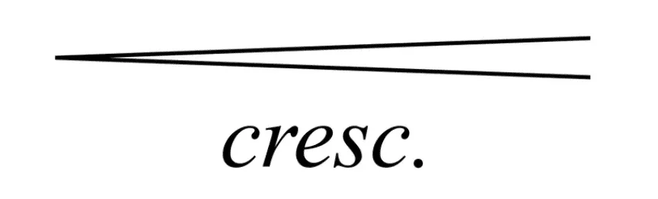,) | No
C major chord | No
Quarter rest (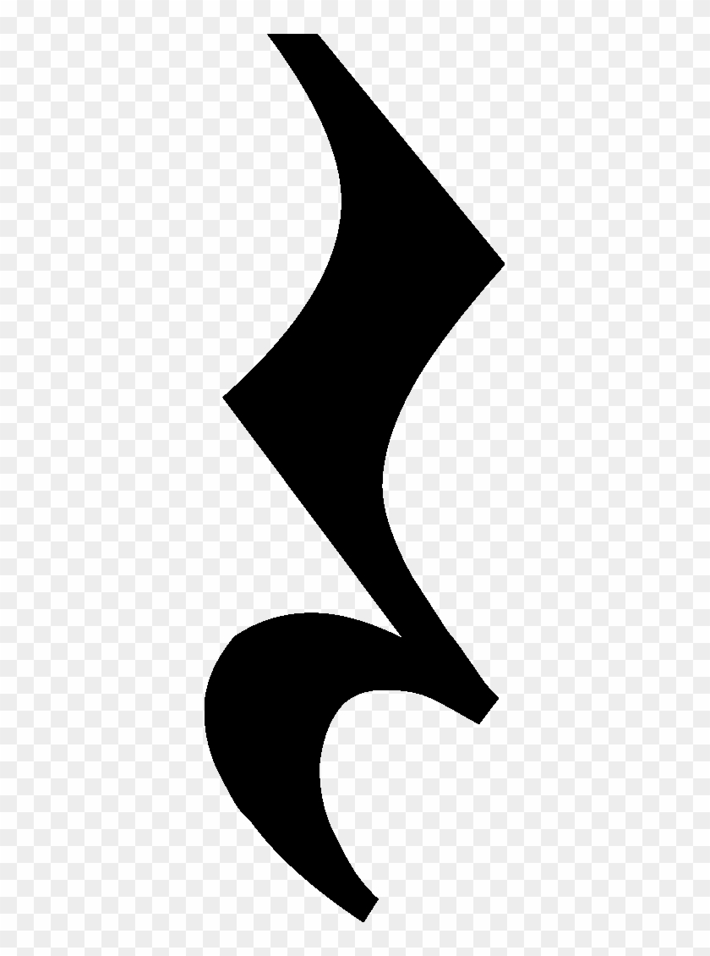) | No
Question 8a (0/1)
Is there information about the speed at which the piece should be played? (e.g., tempo markings like Allegro, Andante, or a BPM number)
1 | “Yes”, at the top of the first measure, above the staff, the word "Allegretto" is clearly indicated. There is no numerical BPM tempo marking.
0 | “No”, or does not recognize the Allegretto.
Question 8b (0/1)
Are there any articulation marks indicating how the piece, or a segment, should be played? (such as ties, legato slurs, dots for staccato, or other articulation marks)
1 | “Yes”, by the end there is a slur that connects the B and A notes [ligadura entre el Si y el La]. There are no others.
0 | “No”, or any other answer: it may say there are many slurs, or that there are any other articulation marks.
Question 8c (0/1)
What clefs, if any, are present in this image of the staff?
1 | “Yes”, “transposing G-Clef, sounds up an octave”, “Sopranino clef”, “Treble clef with a little eight above (only if it mentions the eight, demonstrating it saw it even if it does not understand it)”
0 | “No”, “Treble clef (without mentioning the eight)”, “G-Clef (without mentioning ‘transposing’ or the eight)” or any other answer
Question 9 (0-1)
Based on the musical notation present in the image, how difficult do you think it is to play the excerpt? Rate from 1 to 5, where 1 is easiest and 5 hardest.
1 | “Easy”, 1-2, stating it is a simple melody with easy rhythms
0 | States the melody is difficult or is otherwise unsure given this clear example
Question 10a (melody present) (0/1)
In this excerpt, can the melody “B B C D D” be found in the excerpt?
1 | “Yes”
0 | “No”, or any other answer

Question 10b (melody not present) (0/1)
In this excerpt, can the melody “C D E F# E” be found in the excerpt?
1 | “No”
0 | “Yes”, or any other answer

